**Hosting a Website on Github pages**

Anas Bendania

202110105

CIT112-2 Web Authoring and Design-Section 1

Mr. Tariq Aziz

October 18,2022

**Aims and Objectives:**

The aim for this homework is to host a website on Github. Another aim was working with the java script and creating a game.

**Homework achievement:**

In this week’s homework, I was successful in implementing all the aims which include: creating the famous game wordle, practicing more on the java script such as the “if” statement. Another achievement was hosting a website on Github. Which is essentially a website where you can place the webpages you create and invite people to it so they can view your work.

**Self Learning:**

Through new research methods, I was able to explore more in detail the java script and hosting websites on Github. The website I discovered gave in detail the features and examples of Git. The website described and explained everything I needed to know to get started with Git. [**Reference:** ([Git (github.com)](https://github.com/git-guides))]

**Conclusion:**

In essence, this week’s homework taught me effective research methods, that made my learning easy and broad. And it greatly helped me with understanding more about the java script on a webpage and making a whole webpage that has a game myself from nothing.

**Feedback on:**

*Instructor:* there isn’t much feedback. This homework was good and easy was explained well and direct.

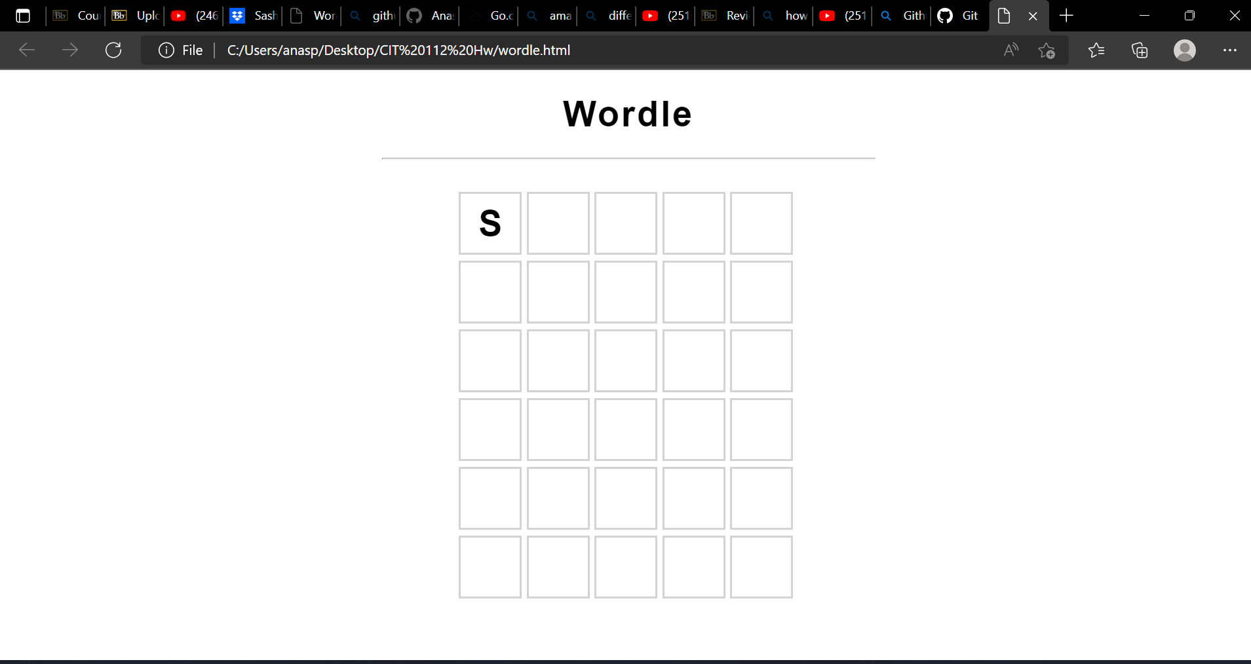

**Html code:**

<!DOCTYPE html>

<html lang="en" dir="ltr">

<head>

<meta charset="utf-8">

<title>Wordle</title>

<link rel="stylesheet" href="wordle.css">

<meta name="viewport" content="width=width-device, initial-scale=0, user-scalable=no">

<meta charset="utf-8">

<script src="wordle.js">

</script>

</head>

<body>

<h1 id="title">

Wordle

</h1>

<hr>

<br>

<div id="board">

</div>

<br><h1 id="answer"></h1>

</body>

</html>

**Java script code:**

var height = 6; //number of guesses

var width = 5; //length of the word

var row = 0; //current guess (attempt#)

var col = 0; //current letter for that attempt

var gameOver = false;

var word= "SQUID";

window.onload= function(){

intialize();

}

function intialize() {

// create the game board

for(let r=0; r<height; r++){

for(let c= 0; c<width; c++){

// <span id="0-0" class="tile">P</span>

let tile = document.createElement("span");

tile.id= r.toString() +"-" + c.toString();

tile.classList.add("tile");

tile.innerText = "";

document.getElementById("board").appendChild(tile);

}

}

// Listen for key Press

document.addEventListener("keyup",(e) =>{

if (gameOver) return;

// alert(e.code);

if ("KeyA" <= e.code && e.code<="KeyZ"){

if (col < width) {

let currTile = document.getElementById(row.toString() + '-' + col.toString());

if (currTile.innerText == ""){

currTile.innerText = e.code[3];

col += 1;

}

}

}

else if(e.code == "Backspace"){

if(0 < col && col <= width){

col -=1;

}

let currTile = document.getElementById(row.toString() + '-' + col.toString());

currTile.innerText = "";

}

else if(e.code == "Enter") {

update();

row+= 1; // start new row

col = 0; // start at 0 for new row

}

if(!gameOver && row==height){

gameover = true;

document.getElementById("answer").innerText = word;

}

})

}

function update(){

let correct = 0;

for(let c = 0; c < width; c++){

let currTile = document.getElementById(row.toString() + '-' + c.toString());

let letter = currTile.innerText;

//Is it in the correct position?

if(word[c] == letter){

tile.classList.add("correct");

correct += 1;

}// Is it in the word?

else if(word.includes(letter)){

currTile.classList.add("present");

}//Not in the word

else{

currTile.classList.add("absent");

}

if(correct == width){

gameOver = true;

}

}

}

**CSS Code:**

body{

font-family: Arial, Helvetica, sans-serif;

text-align: center;

}

hr{

width: 500px;

}

#title{

font-size: 36px;

font-weight: bold;

letter-spacing: 2px;

}

#board{

width: 350px;

height: 420px;

margin: 0 auto;

margin-top: 3px;

display: flex;

flex-wrap: wrap;

}

.tile{

/* Box*/

border: 2px solid lightgrey;

width: 60px;

height: 60px;

margin: 2.5px;

/* Text*/

color: black;

font-size: 36px;

font-weight: bold;

display: flex;

justify-content: center;

align-items: center;

}

.correct{

background-color: #6AAA64;

color: white;

border-color: white;

}

.present{

background-color: #C9B458;

color: white;

border-color: white;

}

.absent{

background-color: #787C7E;

color: white;

border-color: white;

}